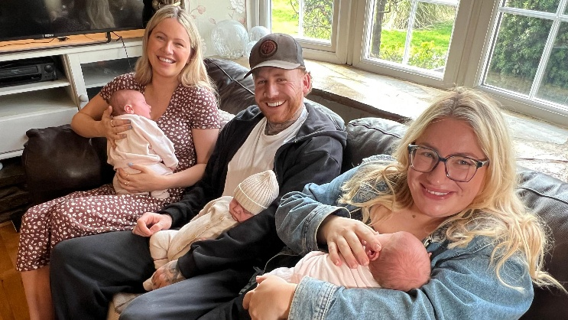
Rare coincidence as three cousins born on same day
"A truly extraordinary coincidence" occurred when three cousins were all born in the same hospital in a single day, an NHS spokesperson has said.
Georgie, from Bridgeyate, South Gloucestershire, gave birth to identical twin girls Frankie and Connie, while her brother Billy welcomed his son Maddox shortly afterwards at the Royal United Hospitals Bath NHS Foundation Trust on 6 February.
Baby Maddox arrived on his due date, while the twins made their appearance a little early.
Georgie said: "It still feels surreal that we all became parents on the very same day. We joked about it happening and then it actually did!"
Georgie added that it was an emotional day for the family.
"It was so special seeing the cousins all together and being able to pop down the hall and see one another on the ward," she said.
A hospital spokesperson said as identical twins only occur in just one in 250 births and only 4–5% of babies are born on their due date, the family's triple arrival "makes for a truly extraordinary coincidence".
The parents said they are now looking forward to joint birthday parties in the years to come.
Billy added that he felt "very happy" when he realised his sister was going to have children at the same time as his girlfriend.
"We couldn't believe it. I feel sorry for their nan and grandad having to spend all the money on birthdays at once," he said.
Maddox' mother Kiera said that the girl cousins are "definitely going to rule the roost".
"He's got an older sister and girl cousins. As you can see, he's loving life," she said.
Clara Bullock, BBC Somerset

